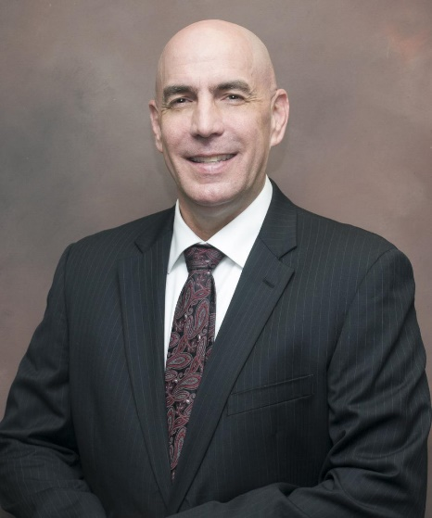
David K. Dunning
Provided by Memphis VA Medical Center
During a 30-year Army career punctuated by service in Operation Desert Storm and a 15-month deployment to Baghdad, David K. Dunning developed a profound respect for his fellow military service members. That unwavering commitment to, and connection with, veterans has prepared Dunning well, he believes, for a new career challenge: overseeing the Memphis VA Medical Center.
"I'm a veteran of 30 years, and while I can't share all the experiences of every veteran who comes to the VA, I do have a valuable context to draw upon because I've been there," he said. "I have three decades of military experience that help me understand where they're coming from, and I understand their issues." Those issues are complex and numerous. The Memphis VA serves nearly 200,000 veterans from Memphis and 53 counties in West Tennessee, North Mississippi and Northeast Arkansas.
A Memphian by birth - his family lived in Somerville, but he was born at the old Baptist Hospital in the Downtown Memphis medical district. After spending his first three years in West Tennessee, Dunning moved with his parents to Columbia, Tennessee, and lived there several years before the family relocated to Syracuse, New York. He spent his teen years there before being awarded an ROTC scholarship that led him to Greenville, South Carolina, where he studied at Furman University, and earned a bachelor's degree in political science. He earned a master's degree in public administration from the University of Missouri at Kansas City and a master's degree in strategic studies from the U.S. Army War College.
His professional experience includes an internship at Walter Reed National Medical Center, a couple of years as a military consultant in Saudi Arabia and medical administrative posts in Germany, Hawaii, Kansas, Louisiana, North Carolina and Texas.

